AIM: Data Types, Creating Tables, Creating Database, Retrieval of Rows using
Select statement, Conditional retrieval of Rows.

Creating Tables
Tables are fundamental components of a relational database where data is stored. To create a table, you use the CREATE TABLE statement, specifying the table name and its columns, along with their data types and constraints.

Procedure :
- Search for XAMPP Control Panel in your device. Open XAMPP Control Panel on your device. The XAMPP control window will open.
- Click on the “Start” button for Apache server and MySQL server. The models will now be initialised. After the initialisation of models has taken place, the “Stop” button will appear.
- Click on the “Admin” button next to the “Stop” button for MySQL server.

- After clicking on the “Admin” button, you will be redirected to http://localhost/phpmyadmin/ .
- To create a database, there are two methods.
- The first method is as follows:

  - Click on the “New” button to create a new database where we want to work with the tables and data types.

  - A window named “Databases” will open.
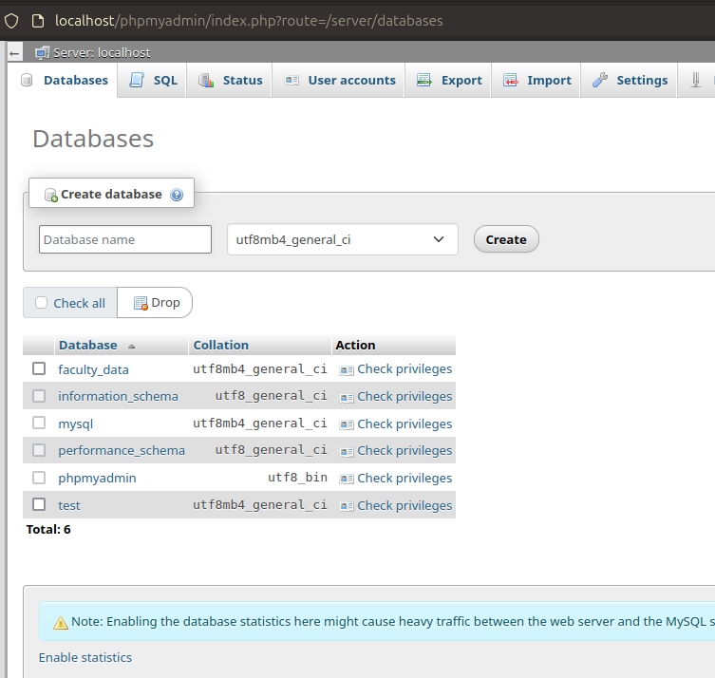

  - the database name field, name the database as “faculty_data" and click on “CREATE” button.

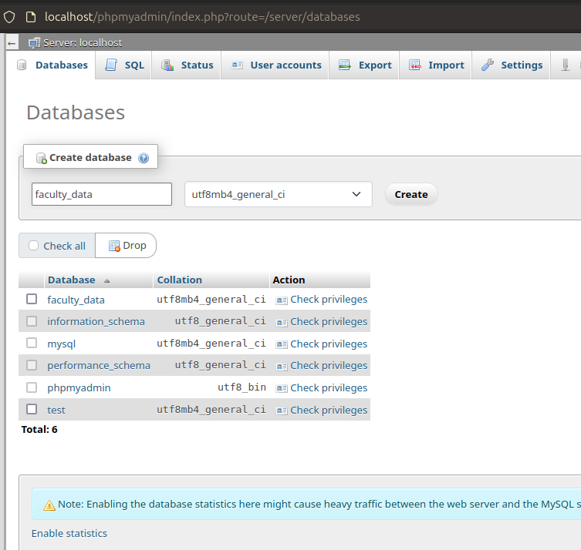

  - Your request will be processed and a new database named “faculty_data” will be created.

7. To create a table navigate to sql section

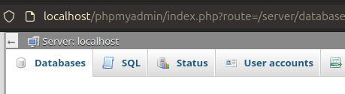

8. open “sql” and then in the query box enter the “CREATE TABLE QUERY”
Following the format;
CREATE TABLE table_name (
column1 datatype constraint,
column2 datatype constraint,
...
columnN datatype constraint
);

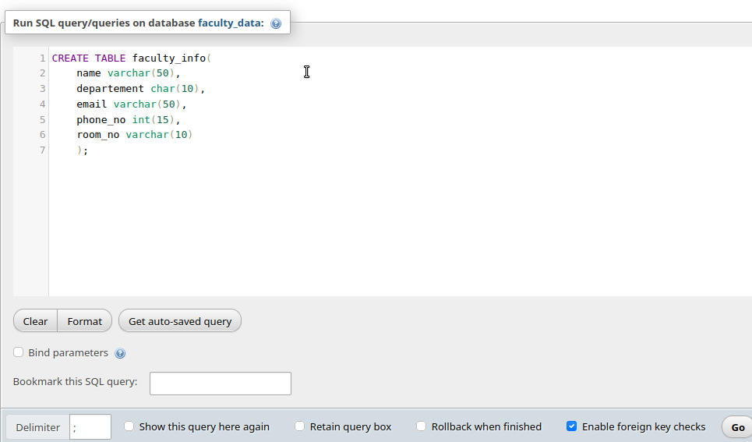
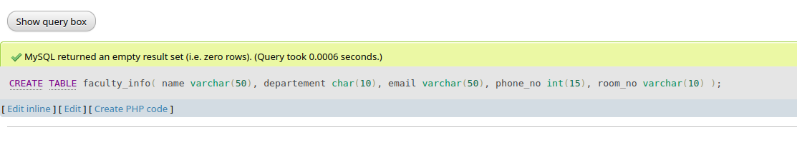
9. click on go and your table with no rows will be created.

Creating Databases
A database is a collection of tables that are related to each other. To create a database, you use the CREATE DATABASE statement, and then you can create tables within that database.

- Write the SQL query - CREATE DATABASE faculty_data; and click on “Go”. button.

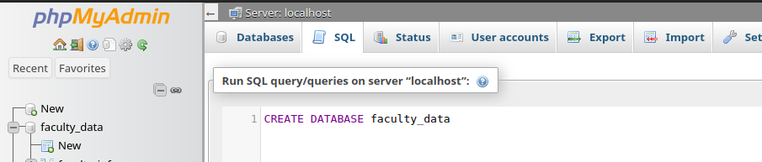
- A database named ‘faculty_data’ will be created.

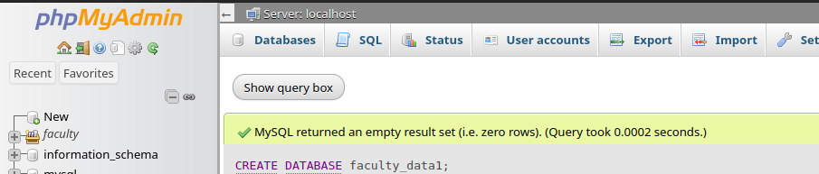

- the SQL query to specify the database to be used – USE faculty_data; and click on “Go” button

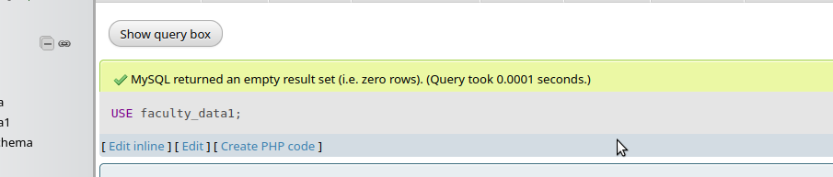
RETRIEVAL OF ROWS USING SELECT STATEMENT:
- In SQL, the SELECT statement is used to retrieve data from one or more tables in a database. Suppose if we want to extract only name and tuition fees column from “tuition and mess fees” table then we will write the select statement as shown in the below picture. SELECT ‘Column Name’ FROM ‘Table Name’
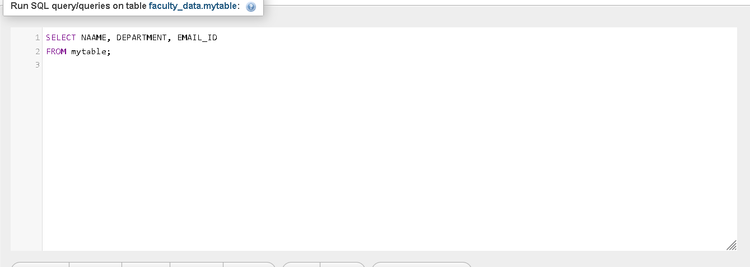
- After clicking on go we will obtain the two columns as shown in the image below.
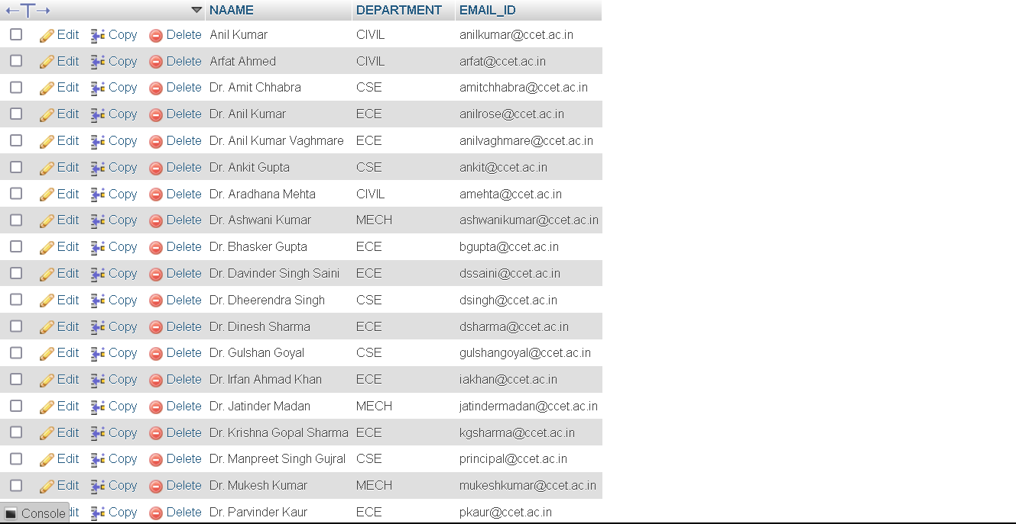

CONDITIONAL RETRIEVAL ROW

1. Conditional retrieval of rows in SQL involves using the WHERE clause to specify conditions that the retrieved data must meet.
syntax given below in the image.
SELECT ‘column 1’, ‘column 2’FROM ‘table name’WHERE condition
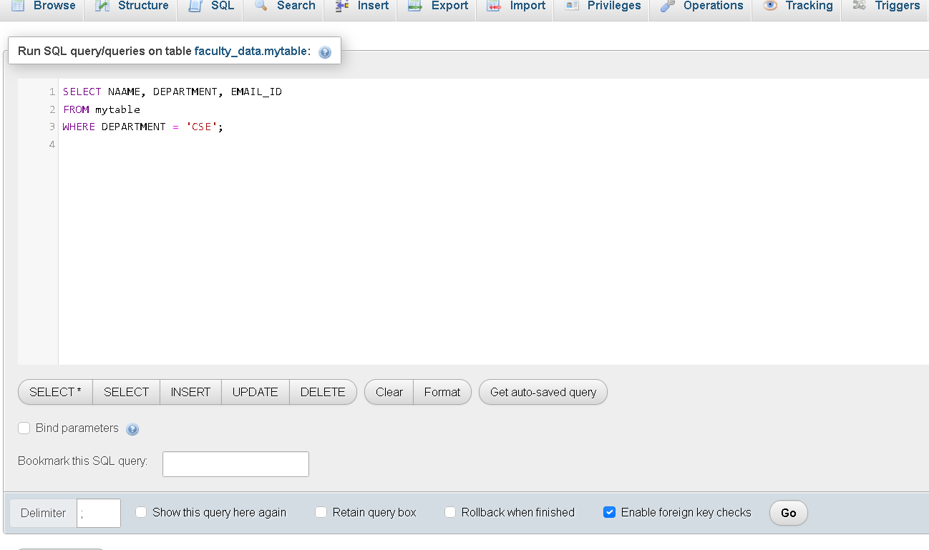

2. After clicking on go we will get a table as shown.
